2020 - CFCE Summer Camp Information

We are excited to release our 2020 summer camps dates. This summer, we are offering several camps in Denver, Loveland, and Aurora, CO. All sessions will run Monday through Friday. The dates for each camp and the tuition rates are listed on the following registration form. We offer a discount for families who register for 4 or more weeks of camp.

Please have a look at the following registration form and respond with your commitment as soon as possible to hold your child’s place. If you would like further information about Conductive Education and what the camp will entail, please do not hesitate to contact Jalyss Zapfletts or Jennifer Doyle at admin@conductiveed.com, or (720)252-2299 for this information.

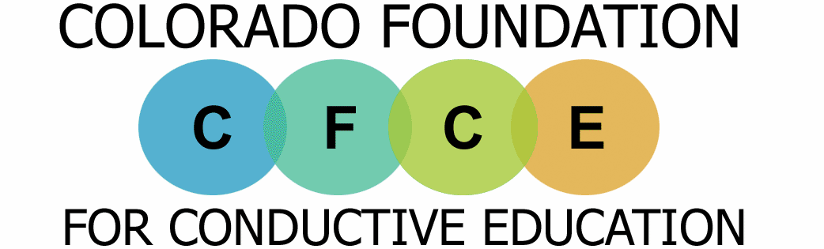
We need to know well in advance who is seriously interested in signing their child up for camp this summer so that we can arrange to hire Conductors and staff members for each camp to cover the number of children attending. Please understand that hiring the Conductors needs to be done months in advance for us to handle their visa requirements, flight, and hotel arrangements.
… Achieving independence through active learning

If you would like to sign up your child for camp, please fill in the registration form and return to CFCE by mail to: CFCE, PO Box 746297, Arvada, CO 80006 by April 1st, 2020. Forms can also be scanned and emailed to: office@conductiveed.com. You must also pay a non-refundable $250 deposit with your application to secure your child’s placement in the summer camp. Later in April, you will receive an invoice for the remaining balance due. You can choose to pay in full or make installments, but the entire balance will be due before the first day of camp. Don’t forget that camp deposits and tuitions can be paid with your credit card online at www.conductiveed.com. Places are limited, so please sign up ASAP. If a camp session is cancelled by CFCE due to lack of participation, your deposit will be refunded. This is the only circumstance for which a deposit refund will be given.

If you have any questions please contact Jalyss at jalyssz@conductiveed.com or call (970)667-0348.

Please forward this form to any other children and families who you think would benefit from Conductive Education. We look forward to hearing from you.

Sincerely,

Jennifer Doyle Chelsea Arenas Phone: (970)667-0348
CFCE Program Director Office Manager Email: office@conductiveed.com
2020 – CFCE Summer Camp Registration Form

Please fill in and return to CFCE by mail to: CFCE, PO Box 746297, Arvada, CO 80006, or scan and email forms to office@conductiveed.com

Parent/Guardian’s Name _______________________________________________________________

Child’s Name and Age _________________________________________________________________

Address _____________________________________________________________________________

Phone Number ______________________ Email Address (required) ____________________________

I would like to sign my child up for the camp(s) selected below and have included (or paid online) the required non-refundable $250 deposit by April 1st, 2020.

______ I have attended CFCE before.

_______This is my first time attending a CFCE Camp, please send me a registration packet.
(An assessment of your child will be necessary. The assessment cost is $100 which will be deducted from the camp tuition. If you decide not to attend camp the $100 will not be refunded but can be applied toward future class sessions.)

REQUIRED: PLEASE MARK YOUR CHILD’S CURRENT MOBILITY LEVEL TO ENSURE CORRECT GROUP PLACEMENT

_____ Low Mobility: Primary mobility aid is a wheelchair. Child is working on floor mobility such as rolling and sitting up and may use a gait trainer for walking.

_____ Mid Mobility: Mobility aid is a walker or manual wheelchair. Child can stand while holding onto something, take steps in a walker, and sit independently.

_____ High Mobility: Primary mobility aid is a simple walker, canes, or can walk independently. Working on free-walking or cane-walking. Can move around a room safely and independently.

_____ *Life Skills Group: Child has minimal motoric difficulties but struggles with motor planning. Working on functional skills such as dressing, following directions, and being active. Designed for those on the Autism Spectrum, Downs, genetic conditions, etc.
*ONLY AVAILABLE IN LOVELAND JUNE 29th – July 10th

PLEASE READ: The group is an important part of the method of conductive education. Therefore, if your child is the only one in their ability level signed up for a certain week we may ask that you move to a different week to create the best groups possible.

Any additional comments about our camps, please feel free to write below:

____________________________________________________________________________

____________________________________________________________________________

____________________________________________________________________________
CONTINUED ON NEXT PAGE

PLEASE MARK PREFERRED WEEKS

Available | Not Available

 | May 26 | June 1 | June 8 | June 15 | June 22 | June 29 | July 6 | July 13 | July 20 | July 27 | Aug 3 | Aug 10 | # of wks
Arvada  9 - 2 |  |  |  |  |  | N/A | N/A
Loveland  9 - 2 | N/A | N/A | N/A |  |  |  |  | N/A | N/A | N/A | N/A | N/A
Aurora  9 - 2 |  |  |  | N/A | N/A | N/A | N/A | N/A | N/A | N/A | N/A | N/A
Arvada
9 – 12p

*Class will not be held on the following dates: May 25 (Memorial Day), June 18th (Annual CFCE Golf Tournament)

TUITION RATES

 | 9 - 2pm | 9 – 12pm*
2 Weeks | $1,750 | $1,050
3 Weeks | $2,625 | $1,575
4 Weeks | $3,000 (save $500 from base price) | $1,920 (save $180)
5 Weeks | $3,750 (save $625) | For children under 7 who may not be able to participate in a full 5-hour session, we offer 3-hour sessions on certain weeks, based on interest. If you are interested, please mark your preferred dates above and initial here: ______
6 Weeks | $4,200 (save $750)
7 Weeks | $4,900 (save $875)
8 Weeks | $5,600 (save $1,000)

No credits for missed days, holidays or if your child is sick.
Weeks are not required to be consecutive to receive discount

**EARLY BIRD: If tuition is paid in full by May 1st a discount of $100 will be applied!**

Signed ___________________________________ (Parent/Guardian) Date_________

Thank you for your registration. We will send a confirmation email soon. We look forward to seeing you this summer!

